2024 STEM CAMP

Junior Pilot
Summer Camp

Two Day Camp
Thursday and Friday
9:00 am – 3:00 pm

Session 1 June 13 and 14 – 8th – 12th graders
Session 2 June 20 and 21 for 6th – 7th graders
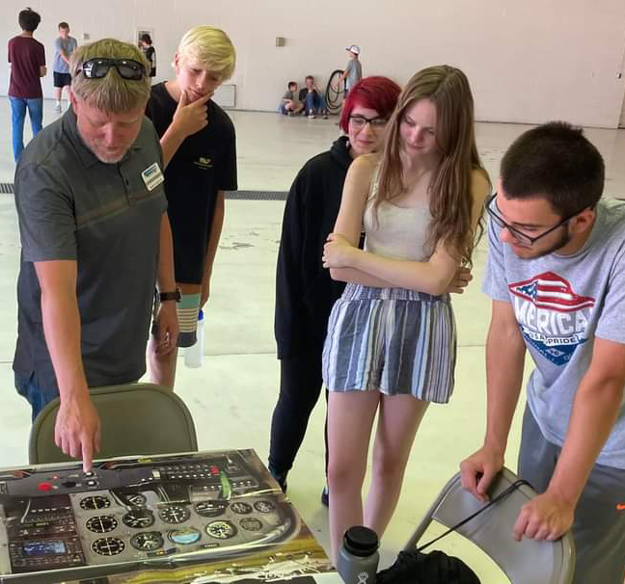
Junior Pilot Camp is a two-day total immersive program for 6th – 12th graders.
Both sessions will have a Discovery Flight in a Cessna 172 Skyhawk. Junior Pilots will learn the basics of flight, tour airport facilities, and plan a cross country flight. The camp will be a mini ground school, as well as explore career opportunities, flight operations, and flight communications. More details and registration can be found on the museum website.

Any questions, please contact Scott Taylor 712-635-1902. Leave a message if no answer.
REGISTER AT www.midamericaairmuseum.org
Camp Fee for the two-day camp is:
$160.00 for members
$180.00 for non-members
Extra $8 for a sack lunch (or bring your own)

Other Summer Events  SUX FLY IN – May 4, 2024  Ready, Set, Drone.  In development | Camps are part of the  727 STEM LEARNING CENTER  Sponsored by FedEx Express  Check website for updates and offerings  If a student has attended before, they can attend again and learn new lessons.  Join as a member and save on the camps.  Follow us on Facebook and Instagram

Registration is open until slots fill.

You can register on the museum website www.midamericaairmuseum.org
OR
Fill in the following form, and return it to the air museum

Student Name ___________________________________________________________________
Address _________________________________________________________________________
School _______________________________________Grade Just Completed ______________
Parent’s/Guardian Name __________________________________________________________
Parent’s/Guardian Email __________________________________________________________
Parent’s Phone Number ___________________________________________________________
Best way to reach you___________________________________________
Does your child require accommodation or special assistance? Please describe. If no special requests or needs type NONE ______________________________________________________
Any food allergies or preferences for your student? If no allergies or preferences type NONE ________________________________________________________________
How did you hear about this camp?__________________________________________________

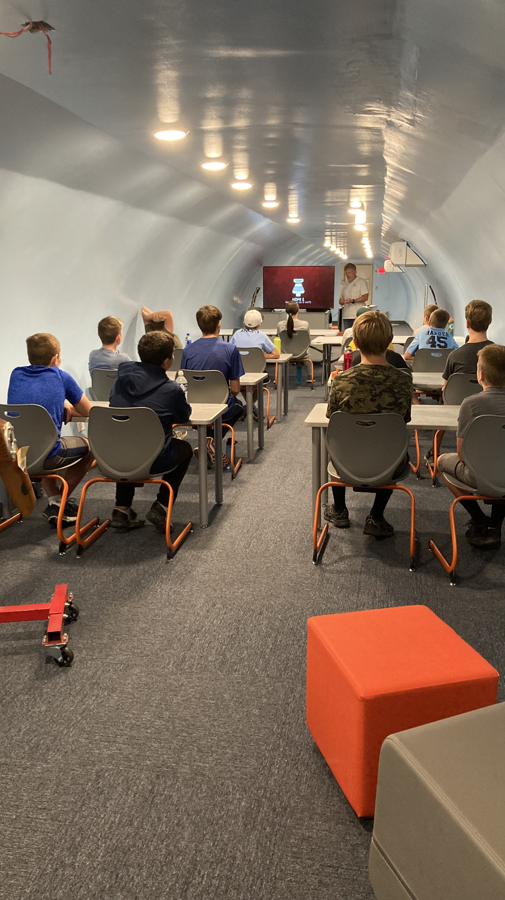
Register for
Junior Pilot Camp
Two Day Camp for 6th – 12th graders
Session 1 June 13 and 14 8th – 12th graders
Session 2 June 20 and 21 6th – 7th graders
________ $160.00 for members
________ $180.00 for non-members

T-Shirt Size Adult ___ S ___ M ___ L ___ XL ___ XXL

Amount Enclosed $_______________
Make check payable to
Mid America Museum of Aviation & Transportation
Mail to: P.O. Box 3525,
Sioux City, IA 51102
Or drop off in person at Thursday, Friday, or Saturday
10:00 am – 4:00 pm (or call for an appointment)
2600 Expedition Court
Sioux City, IA 51111

